Thoughts from your President, Maxine Paul

Happy New Year, Everyone!
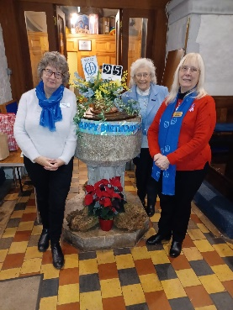
How did your Christmas go? Well, mine was a lovely, busy mixture of spending time with family and friends enjoying the festivities and lots of church services. My last few MU engagements before Christmas saw me celebrating 95 years of MU in Rainham at St Helen’s and St Giles’ at their carol service, with members whose own service to MU totalled well over 500 years… so many congratulations to them. The next day I visited Wickford and Runwell Branch for Midday Prayers at St Andrew’s followed by a sumptuous home-cooked Christmas lunch with 30 members and friends. Finally, my own Branch peace-themed carol service followed by tea and mince pies. Isn’t it wonderful how worship and fellowship, sharing food go hand-in-hand?

I have been following the Church of England #Follow the Star: Join the Song reflections for Christmas and New Year and, on 27th December as I was preparing to write this letter, I was struck by the theme for the day “How silently the wonderous gift is given” and the reading 1 Kings 19:11-12. I quote:

“After the drama of a birth comes a moment of calm. Amidst the struggles of the world, at the centre of Christmas we find intimacy and peace: Jesus, held – and holding.
We can become so busy preparing for Christmas that it’s over long before the food is finished or torn wrapping paper cleared. And have we had time to be present to the most important guest of all – Jesus, the heavenly guest whose arrival on earth our
Christmas celebrations mark?
Think of a guest who leaves you feeling heard, healed, replenished. My grandmother used to be like that – there for us. At the centre. The still centre. Often busy at the sink washing up or peeling potatoes – but always listening. It is only when such a guest leaves or passes on that you long for them to return. It’s in their attentiveness that you realise you are loved.”

Can we try and make space to be attentive this year – to someone who needs to be heard, to the wonder of creation, to God’s still, small voice?

Love and blessings. Maxine x

Lord, whether we're leaving behind a year of joy and blessing or trials and difficulties, we pause to give thanks. We thank you that you are always with us, every single day of every single year. Let us be ever mindful of your presence in the year ahead and make space to be attentive to you and to others, even when life is busy. Amen.

Fundraising update
The MU Christmas campaign successfully hit its Big Give fundraising target. A huge thank you to everyone who donated – your support will enable MU to run savings and skills development groups in Tanzania, with the aim of supporting 3000 women to establish or grow businesses and gain confidence and skills to take on leadership roles.
The appeal will stay open into the new year. To donate visit www.mothersunion.org/christmas23

This year’s Make a Mothers’ Day campaign will focus on Gifts of Dignity. Members will receive a gifts booklet and appeal letter towards the end of January.

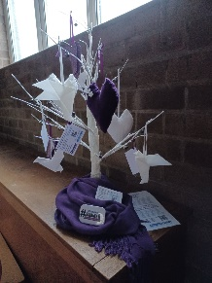
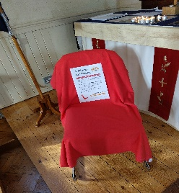
RISE UP campaign and 16 Days of Activism
Members across the diocese marked the UN 16 Days of Activism campaign with services and displays in their churches. Thank you to everyone who took part for all you have done in raising awareness of gender-based violence and abuse.

The new RISE UP against domestic abuse campaign will ensure that we can continue to raise awareness of this issue 365 days a year. Churches are encouraged to take part in the RISE UP challenge, working towards the bronze, silver, or gold RISE UP award. If your branch or church want to be assessed for an award, then please complete the RISE UP monitoring form by 31st January available at www.mothersunion.org/riseup

Clewer Initiative Lent Resource
The season of Lent begins on 14th Feb 2024. This year the Clewer Initiative has combined with the World Council of Churches to launch a substantial new resource for Lent called True Freedom. This six-week course draws on themes from the book of Galatians and encourages individuals and churches to respond to modern slavery in their communities. To find out more about the course and download the materials visit www.truefreedom24.com

Provincial Gathering
Canterbury Province is currently planning a Provincial Gathering to take place on 22nd June 2024. The gathering will focus on fellowship and prayer with a chance to share details of unique and successful projects from each diocese. Any member that would be interested in attending should contact mugathering2024@muoxford.org.uk to indicate their interest by Friday 26th January so that the organisers have an idea of numbers.

Crafting
A reminder that any knitted items going out should be checked for choking hazards and a luggage style label attached indicating the item has been checked prior to sending but does not conform to toy safety standards. Example labels have been produced by the diocese and can be provided on request by contacting the diocesan secretary

News from Mary Sumner House
- The Mothers’ Union Safeguarding Policy and Procedure for Britain is now on the central website Mothers' Union Britain Safeguarding Policy and Procedure | Mothers' Union (mothersunion.org)
- For regular updates on central MU work, sign up to the central e-newsletter on this link: https://mothersuniononline.org/p/1I8Y-G0K/sign-up-to-the-mothers-union-mailing-list

Dates for the dairy
- Jan 2023 - Dec 2024 RISE UP Against Domestic Abuse 365 days of the year
- Provisional Spring Members Meeting – evening of 5th June, Chapter House
- Provisional date for Canterbury Province Provincial Gathering - Saturday 22nd June 2024
- Provisional AGM and Annual Thanksgiving Service – 18th November, Cathedral

